

**London property price report - June 2016**

**Independent, free, expert advice on housing**

Buying, selling or investing in today’s variable market means you need to take a great deal of care before making a decision. It’s essential to secure independent, up-to-date advice you can trust. Kate and her team from [Propertychecklists.co.uk](http://www.propertychecklists.co.uk/) make it easy to access the information and support you need FREE of charge.

Although London is often reported as ‘one market’, it really isn’t. From our analysis there are thousands of markets, just in Greater London, but we break this down for you into the 32 London Boroughs, so ‘click here’ if you just want to see how your own Borough has performed.

**Summary of London property price reports**



**Kate Faulkner comments on the London market:**

*We do keep hearing that the property market in the Capital is slowing, but it’s unlikely that most ‘normal’ buyers won’t be feeling that at the moment, as it’s mostly areas like Kensington and Chelsea, Fulham and Hammersmith where prices easily end up being £1 million for a pretty normal house or flat. Overall though the Rightmove ‘lead indicator’ shows that inflation in the London housing market has dropped back, while the UK HIP data which tends to be three or more months out of date (but accurate) is still showing signs of strong growth. Finally, it’s worth noting that the UK HPI data shows an average of £472,000 for a London property as opposed to the huge average shown by Rightmove which is for all properties, including those on sale for tens of millions of pounds!*

 *Source:* [*UK HPI*](https://www.gov.uk/government/collections/uk-house-price-index-reports)

 *Source:* [*UK HPI*](https://www.gov.uk/government/collections/uk-house-price-index-reports)

**Kate Faulkner comments on the London high growth areas:**

*If we were filling in this table a few years ago the best risers would have been the likes of Haringey, Camden and Hammersmith. However, we’ve seen a real ‘ripple’ effect on property prices in the London Boroughs as the central regions started to rise first, some only falling for just nine months before rising rapidly again and now we are seeing the Boroughs on the very outskirts of Greater London reaping the rewards for homeowners of double digit property price growth.*

**Does price inflation differ depending on who’s buying?**

**Kate Faulkner comments on the London market:**

*What’s important to bear in mind with regards to London though is the great differences in property prices via each London Borough but also between first time buyers versus someone that already owns a home. In the stats below, it shows that FTBs spend (on average) £412,500 on a property (so some more/some less) while for those who own already, because of their increased wealth through property price growth and a strong market due to the shortage of properties versus demand, they can afford to pay on average £533,313 - that’s 30% more than FTBs.*

*Although the stats below show for the HPI index (which measures past price growth), the Rightmove stats show that annually, prices are down quite substantially at the top end of the market while price growth trends for FTBs and Second Steppers seems to be reducing too.*

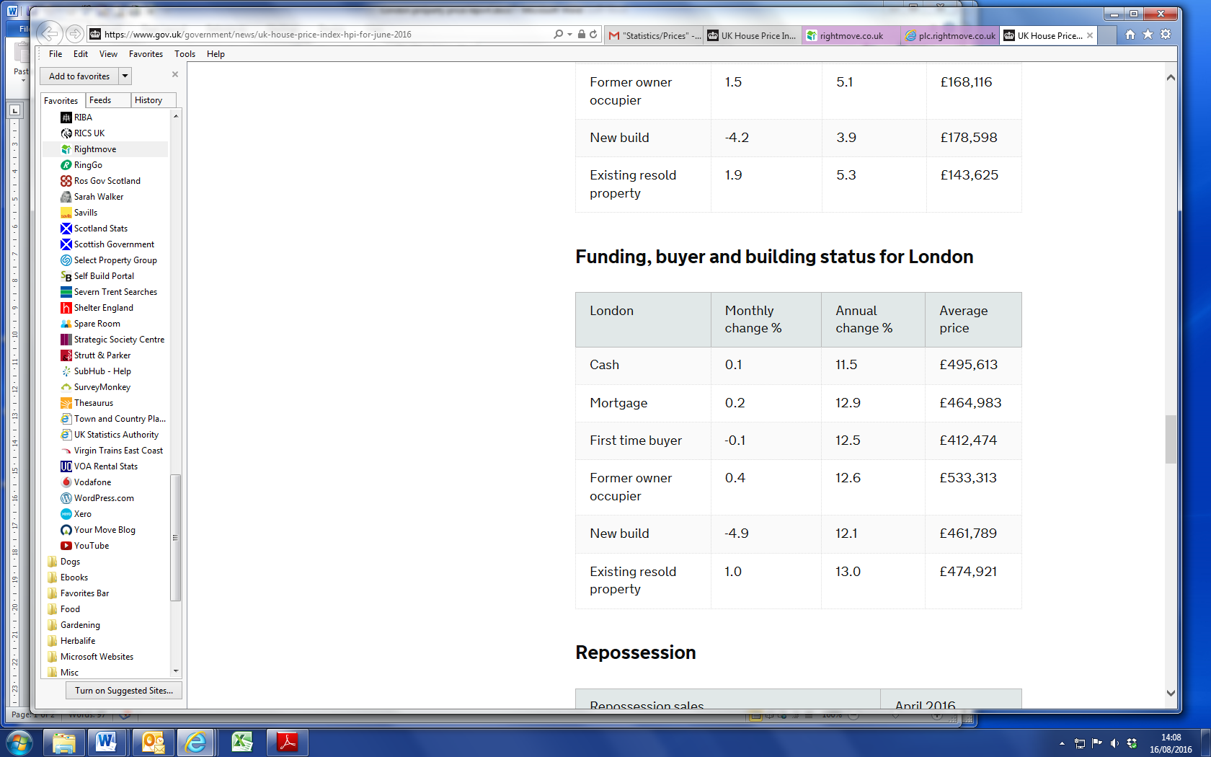

*Source:* [*UK HPI*](https://www.gov.uk/government/collections/uk-house-price-index-reports)

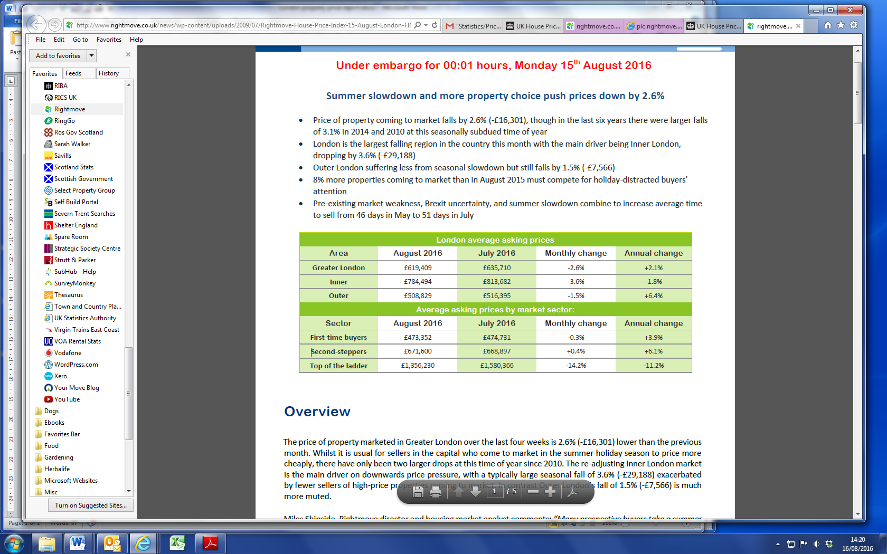

*Source:* [*Rightmove HPI*](http://www.rightmove.co.uk/news/house-price-index)

**The number of properties sold in London are sliding post the Brexit Vote and Stamp Duty increase**

[*LSL Acadata HPI*](http://www.lslps.co.uk/) *“In terms of transactions, looking at Q2 2016 and comparing with the same three months one year earlier, we are currently seeing a 35% reduction in transactions in London, or -9, 150 fewer properties sold, although this figure will change marginally as more data emerges, particularly relating to June 2016 sales. This reduction is a consequence of the surge in sales that took place in March 2016, immediately prior to the introduction of the 3% surcharge in stamp duty on second homes and buy-to-let properties in April. Sales were brought forward into March at the expense of sales in the following three months.*

*“The largest reductions in sales were in Kensington and Chelsea, down 60%, followed by the City of Westminster, down by 56%, with flats being the predominant property type in both boroughs.*

*“All 33 boroughs in London saw a reduction in sales in Q2 2016 compared to Q2 2015, with the smallest decline in sales being in Barking and Dagenham, but even here sales dipped by 18% over this three month period.”*

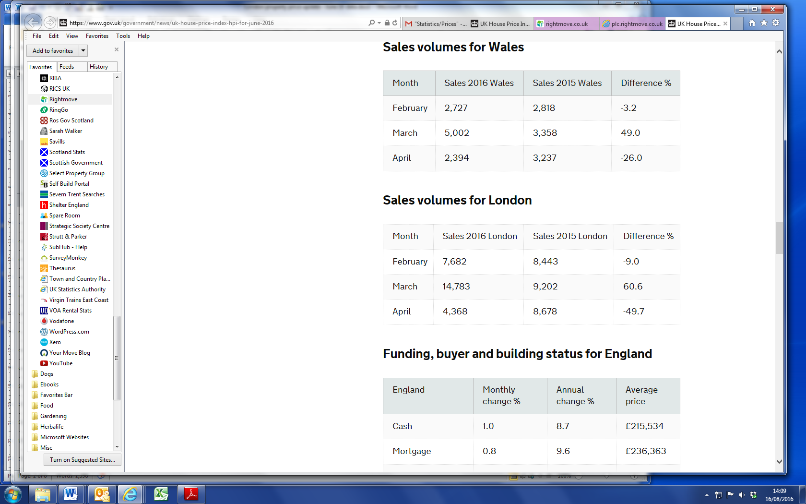*Source:* [*UK HPI*](https://www.gov.uk/government/collections/uk-house-price-index-reports)

**Kate Faulkner comments on transactions, demand and supply:**

*The map from LSL Acadata HPI below shows that all areas are looking at selling less in Q2 versus Q3, but with the stamp duty change and the Brexit vote on top, it’ll be October/November time before we can see some real trends.*

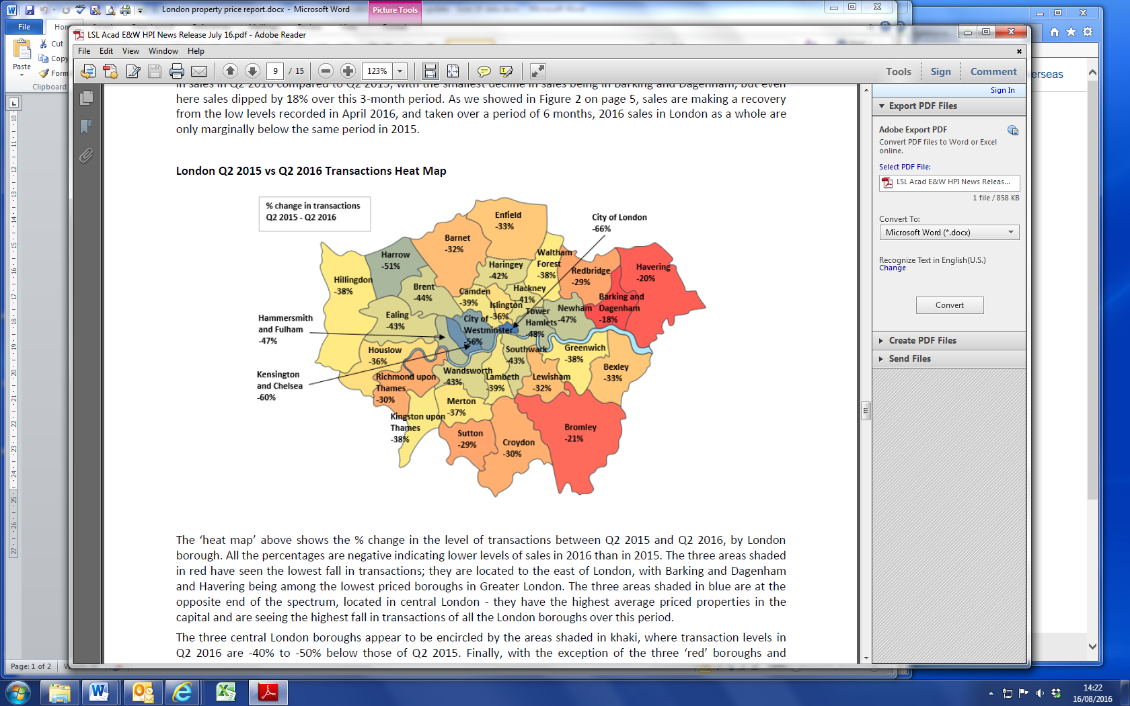

*Source:* [*LSL Acadata HPI*](http://www.lslps.co.uk/)

Finally, time to sell wise, according to Rightmove, the fall in sales and in demand and steadying of house prices means the average time to sell is around six weeks - pretty much a ‘norm’ for the market.

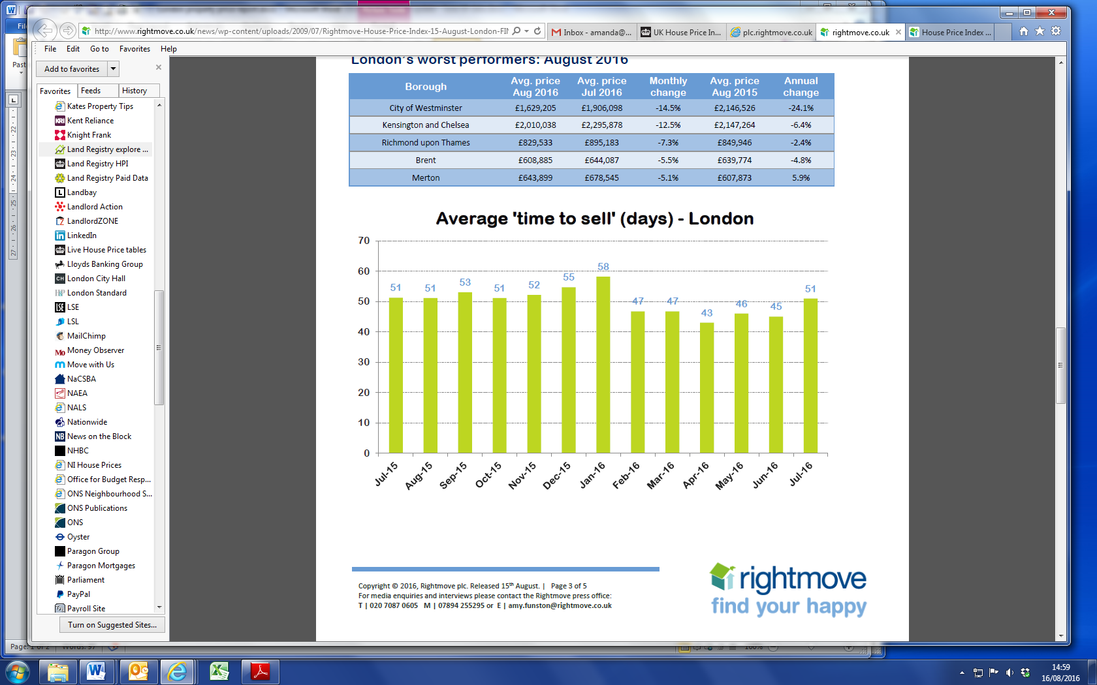

*Source:* [*Rightmove HPI*](http://www.rightmove.co.uk/news/house-price-index)

**Good news from a building perspective!**

[*Savills*](http://pdf.euro.savills.co.uk/uk/residential---other/brexit-briefing--the-impact-on-residential-development-21-july-2016.pdf) “*In London, sales of new homes have held up better than expected. Momentum has been maintained with renegotiations of between 5% and 10% off the agreed price. These adjustments must be seen against the backdrop of a London development market moving into the next phase of the cycle.*

*“The number of both new build sales and housebuilding starts have been declining for the past 18 months, whilst the number of completions has gradually increased and has now overtaken sales and starts for the first time since 2012. After a prolonged period of strong house price growth, affordability in the mainstream London market is stretched which is likely to limit future demand and curb further house price growth.”*

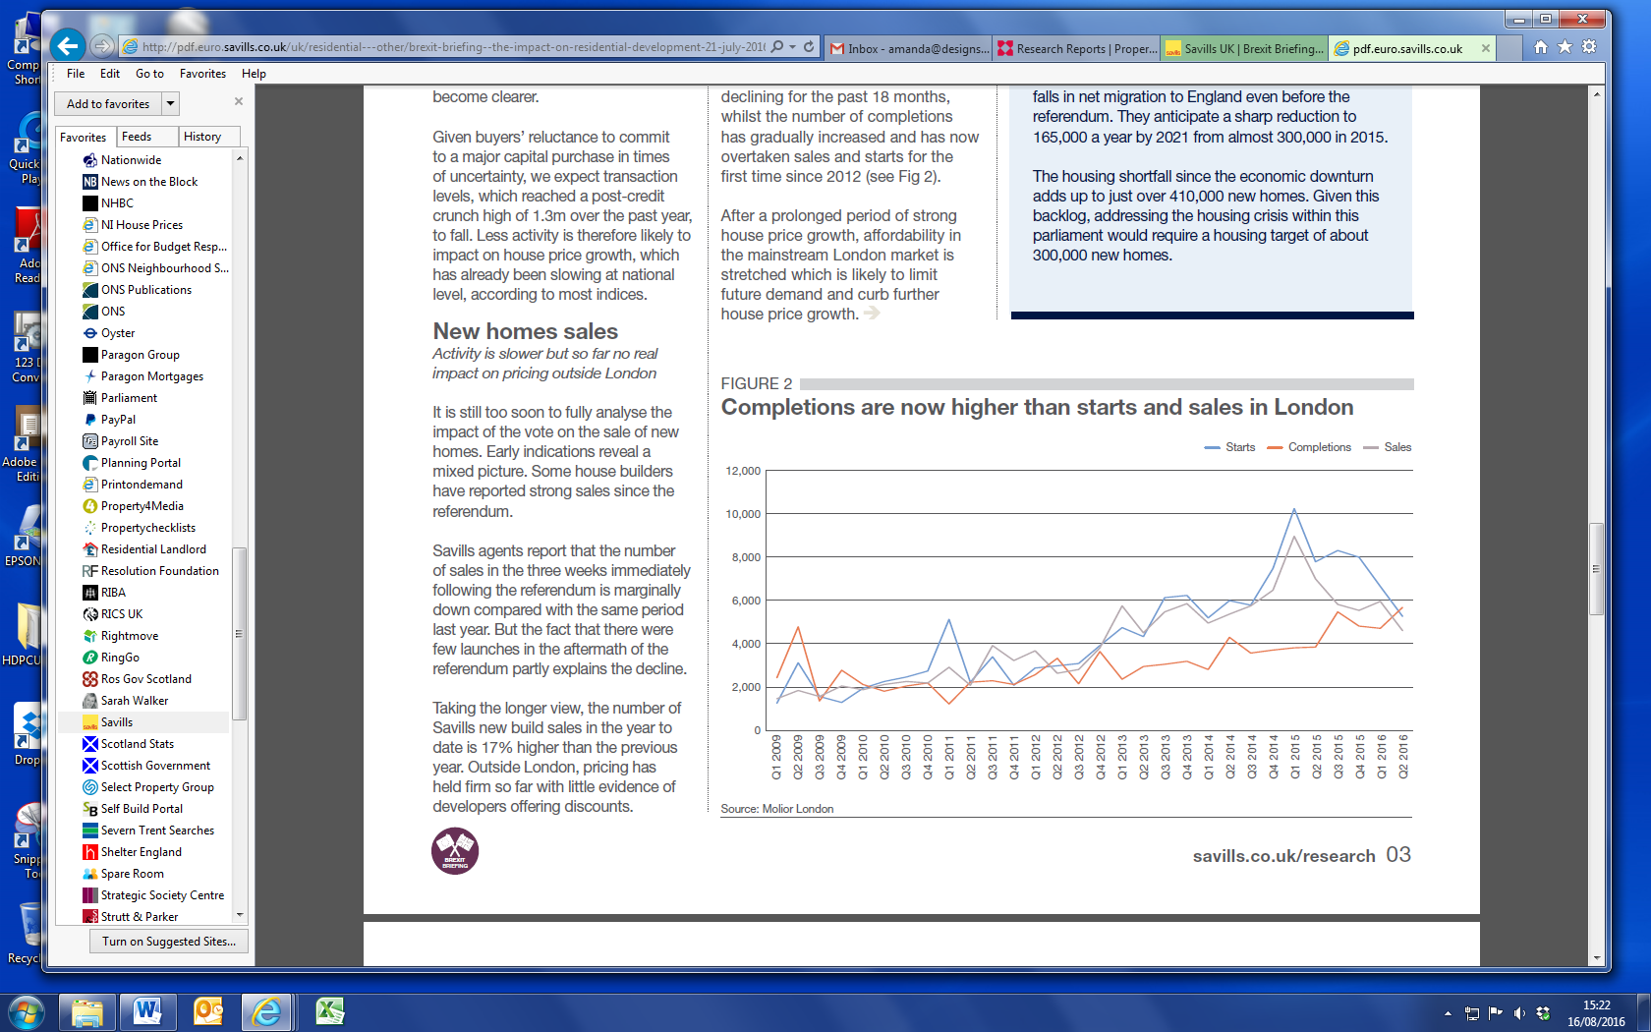

*Source:* [*Savills*](http://pdf.euro.savills.co.uk/uk/residential---other/brexit-briefing--the-impact-on-residential-development-21-july-2016.pdf)

**Appendix 1**

**Current performance by individual London borough**

The table below shows how your Borough is performing year on year now and whether this performance is above or below the long term annual increase.



*Source:* [*UK HPI*](https://www.gov.uk/government/collections/uk-house-price-index-reports)

**Appendix 2**

**London prices risk analysis**

This table shows you what happened in each borough during the Credit Crunch so if you buy now and the market falls, it gives an indication of what the market might fall by and also how long prices may fall for before they bottom

out and start rising again.



*Source:* [*UK HPI*](https://www.gov.uk/government/collections/uk-house-price-index-reports)

**Kate’s guide to the individual indices**

* [Rightmove](http://www.rightmove.co.uk/news/house-price-index) - Useful to measure average time to sell and sellers’ sentiment*.* *(E & W)*
* [LSL Acadata HPI](http://www.lslps.co.uk/) – Analyses Land Registry figures, separates out London, good analysis on transactions.  
  *(E & W)*
* [UK HPI](https://www.gov.uk/government/collections/uk-house-price-index-reports) – Tracks sold property price data, good for accurate information, but doesn’t reflect current market conditions. *(E,W,S & NI)*

**Independent, free, expert advice on housing**

Buying, selling or investing in today’s variable market means you need to take a great deal of care before making a decision. It’s essential to secure independent, up-to-date advice you can trust.

Kate and her team from [Propertychecklists.co.uk](http://www.propertychecklists.co.uk/), make it easy to access the information and support consumers’ need via FREE of charge eBooks, checklists, daily articles and one-to-one advice:

* [First time buyer eBook](http://eepurl.com/bTjsi5)
* [Buying your first home](http://www.propertychecklists.co.uk/articles/How-Can-I-Buy-a-House)
* [Trading up](http://www.propertychecklists.co.uk/articles/trade-up-property)
* [Buy to let](http://www.propertychecklists.co.uk/articles/How-to-Let-a-House)
* [Renting a property](http://www.propertychecklists.co.uk/articles/How-to-Rent-a-Property)
* [Selling a property](http://www.propertychecklists.co.uk/articles/How-Do-You-Sell-a-House)

**For industry professionals**

If you are you a property professional or journalist who needs up-to-date, accurate facts and figures about residential property, subscribe to our [Property Information Portal](http://www.designsonproperty.co.uk/categories/Property-Information-Portal).

**For media professionals**

**If you need Kate to appear on TV, radio or for general comment, please contact directly:**

Kate Faulkner, Property Market Analyst and Commentator

Websites: [Kate Faulkner](http://www.katefaulkner.co.uk/)[Propertychecklists.co.uk](http://www.propertychecklists.co.uk/)

Email: [kate@designsonproperty.co.uk](mailto:kate@designsonproperty.co.uk)

Telephone: **01652 641722**

**About** [Kate Faulkner](http://www.katefaulkner.co.uk/)

Kate has written six property books including four for the consumer organisation Which? – Buy, Sell and Move House; Renting and Letting; Develop your Property and Property Investment Handbook. Kate presents at a seminar almost every week to landlords, investors and first-time buyers, and is often asked to chair debates and present at industry conferences.

From a media perspective, Kate’s appearances include BBC Breakfast News, Your Money, GMTV, ITV, Radio 4 You and Yours, The Big Questions and 5Live. In the last 12 months, Kate has carried out numerous TV and radio interviews, has been quoted every month in major newspapers and magazines and been featured in many local newspapers.

For more information contact Kate Faulkner directly on **07974 750562** or [kate@designsonproperty.co.uk](mailto:kate@designsonproperty.co.uk)